Course One

Foundations of Data Science


Instructions
Use this PACE strategy document to record decisions and reflections as you work through this end-of-course project. You can use this document as a guide to consider your responses and reflections at different stages of the data analytical process. Additionally, the PACE strategy documents can be used as a resource when working on future projects.

Course Project Recap
Regardless of which track you have chosen to complete, your goals for this project are:
- Complete the PACE Strategy Document to plan your project while considering your audience members, teammates, key milestones, and overall project goal.
- Create a project proposal for the data team.

Relevant Interview Questions
Completing this end-of-course project will empower you to respond to the following interview topics:
- As a new member of a data analytics team, what steps could you take to get 'up to speed' with a current project? What steps would you take? Who would you like to meet with?
- How would you plan an analytics project?
- What steps would you take to translate a business question to an analytical solution?
- Why is actively managing data an important part of a data analytics team's responsibilities?
- What are some considerations you might need to be mindful of when reporting results?

Reference Guide
This project has three tasks; the following visual identifies how the stages of PACE are incorporated across those tasks.
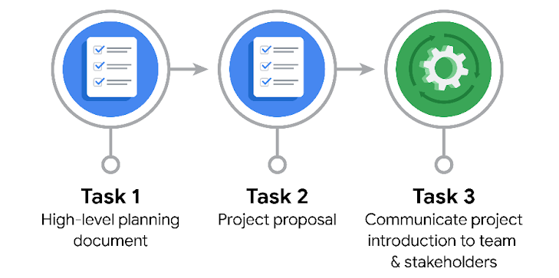

Data Project Questions & Considerations
PACE: Plan Stage

- Who is your audience for this project?
The executives at TLC.

- What are you trying to solve or accomplish? And, what do you anticipate the impact of this work will be on the larger needs of the client?
We are trying to achieve the goal of allowing TLC to estimate taxi fares before a ride. I believe
that by doing this, TLC will be better able to determine the fares of taxis according to the
distance, type of vehicle the taxi is and other factors. This will allow TLC to monitor and
regulate New York’s taxis and cabs.

- What questions need to be asked or answered?
How do taxi fares vary with the distance needed to travel?
How do taxi fares vary with the type of vehicle that is used?
How do taxi fares vary with each day (weekends, weekday, holidays)?

- What resources are required to complete this project?
All of the data that TLC has gathered from the over 200,000 taxi and limousine licensees.
The Python notebook.
The goals of the stakeholders

- What are the deliverables that will need to be created over the course of this project?
The model relating the taxi fare to each of the factors that affect it.
The dataset that is obtained after cleaning and organizing all the data.

THE PACE WORKFLOW
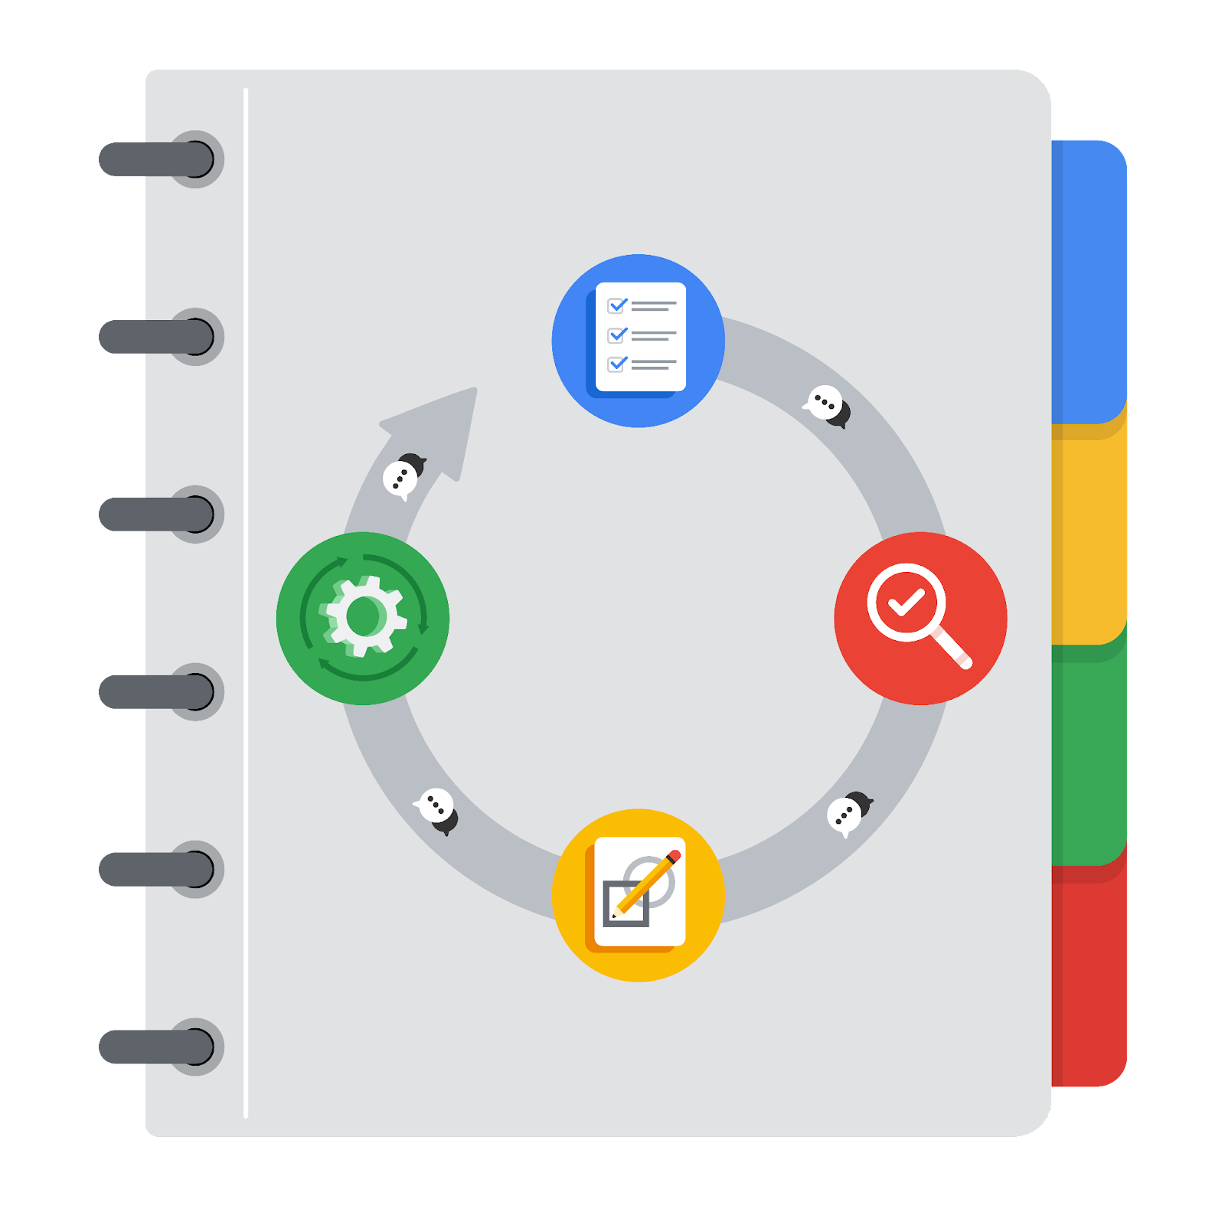
[Alt-text: The PACE Workflow with the four stages in a circle: plan, analyze, construct, and execute.]

You have been asked to demonstrate for the company's data team how you would use the PACE workflow to organize and classify tasks for the upcoming project. Select a PACE stage from the dropdown buttons. A few tasks involve more than one stage of the PACE workflow. Additionally, not every workplace scenario will require every task. Refer back to the Course 1 end-of-course portfolio project overview reading if you need more information about the tasks within the project.

Project tasks
Following are a group of tasks your company’s data team has determined need to be completed within this project. The data analysis manager has asked you to organize these tasks in preparation for the project proposal document. First, identify which stage of the PACE workflow each task would best fit under using the drop down menu. Next, give an explanation of why you selected the stage for each task. Review the following readings to help guide your selections and explanation: The PACE stages and Communicate objectives with a project proposal. You will later reorder these tasks within a project proposal.

- Evaluating the model: Execute
Why did you select this stage for this task?
Evaluating the model comes after constructing the model and involves extracting findings from the model and presenting them.

- Conduct hypothesis testing: Analyze and Construct
Why did you select these stages for this task?
Conducting hypothesis testing requires organizing and cleaning data so that it is usable for constructing models that can be then used for hypothesis testing.

- Begin exploring the data: Analyze
Why did you select this stage for this task?
This is the first step after obtaining the data.

- Data exploration and cleaning: Analyze and Plan
Why did you select these stages for this task?
This involves cleaning the data and then uncovering relationships within it.

- Establish structure for project workflow (PACE): Plan
Why did you select this stage for this task?
This requires planning out the project workflow.

- Communicate final insights with stakeholders: Execute
Why did you select this stage for this task?
This is the final step after obtaining all of the insight from the data.

- Compute descriptive statistics: Construct
Why did you select this stage for this task?
This involves applying statistical inferences.

- Visualization building: Analyze and Construct
Why did you select these stages for this task?
This requires cleaning up and organizing the data as well as constructing models.

- Write a project proposal: Plan
Why did you select this stage for this task?
This involves planning out the project completely in advance.

- Build a regression model: Analyze and Construct
Why did you select this stage for this task?
This requires cleaning up the data and EDA as well as determining relationships within the data to build the regression model.

- Compile summary information about the data: Analyze
Why did you select this stage for this task?
This comes after all of the data has been analyzed and the required models have been conducted and insights have been obtained

- Build machine learning model: Construct
Why did you select this stage for this task?
This requires building a model

